***Assingning tasks from coach***

1) Create a BO "InstanceDetails" with the elements ProcessInstance Name, ProcessId,TaskId.

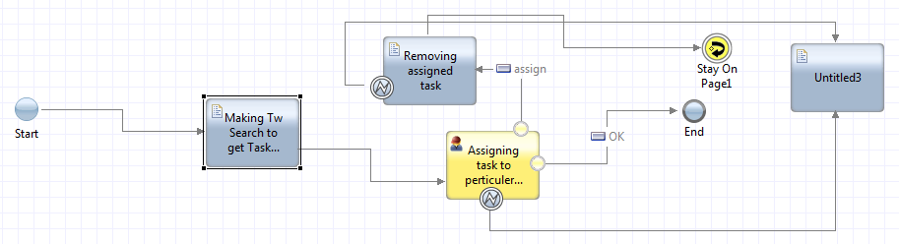

Fig1:Heritage Human Service

2)Create a Heritage Human Service and define a private variable of type "InstanceDetails" what we created in step1.

* Take a script Component inorder to fetch Processname, Process id and task Id we will use Twsearch Api. At the same time we need to fetch users of a team to assign tasks. Following code to fetch task,process details

**var** Search= **new** TWSearch();

**var** processInstanceName = **new** TWSearchColumn();

processInstanceName.type=TWSearchColumn.*Types.*ProcessInstance;

processInstanceName.name=TWSearchColumn.*ProcessInstanceColumns.*Name;

**var** processInstancestatus = **new** TWSearchColumn();

processInstancestatus.type=TWSearchColumn.*Types.*ProcessInstance;

processInstancestatus.name=TWSearchColumn.*ProcessInstanceColumns.*Status;

**var** processInstanceId = **new** TWSearchColumn();

processInstanceId.type = TWSearchColumn.*Types.*ProcessInstance;

processInstanceId.name =TWSearchColumn.*ProcessInstanceColumns.*ID;

**var** taskId = **new** TWSearchColumn();

taskId.type= TWSearchColumn.*Types.*Task;

taskId.name= TWSearchColumn.*TaskColumns.*ID;

Search.columns= **new** Array(processInstanceName,processInstanceId,taskId);

**var** instanceCheck=**new** TWSearchCondition();

instanceCheck.column=processInstancestatus;

instanceCheck.operator=TWSearchCondition.*Operations.*Equals;

instanceCheck.value="Active";

**var** condInstanceID = **new** TWSearchCondition;

condInstanceID.column = processInstanceId;

condInstanceID.operator = TWSearchCondition.*Operations.*GreaterThan;

condInstanceID.value = "3930670";

Search.conditions = **new** Array(instanceCheck,condInstanceID);

Search.organizedBy = TWSearch.*OrganizeByTypes.*Task;

**var** results = Search.execute();

tw.local.InstanceDetails = **new** tw.object.listOf.InstanceDetails();

**for**(**var** i = 0; i < results.rows.length; i++) {

**var** row = results.rows[i];

tw.local.InstanceDetails[i] = **new** tw.object.InstanceDetails();

tw.local.InstanceDetails[i].ProcessInstanceName = row.values[0].toString();

tw.local.InstanceDetails[i].ProcessInstanceId = row.values[1].toString();

tw.local.InstanceDetails[i].TaskId = row.values[2].toString();

}

tw.local.UserMembers= **new** tw.object.listOf.NameValuePair();

**var** TeamDetails = **new** tw.object.Team();

TeamDetails=tw.system.org.findTeamByName(tw.local.TeamName);

**for** (**var** j=0;j<TeamDetails.users.length;j++)

{

tw.local.UserMembers[j]= **new** tw.object.NameValuePair();

tw.local.UserMembers[j].name=TeamDetails.users[j].fullName;

tw.local.UserMembers[j].value=TeamDetails.users[j].name;

}

After Script component drop a coach

* Drop a horizontal section with in coach which will be appear in left side panel of coach.
* Click on variable tab there you can find a variable of BO type drag that variable inside Coach and make sure every element dragged is of type BPM UI if not change to BPMUI type.
* 3)Also select a single dropdown of type BPMUI to assign select a user. Open its properties
* Now drop a button from pallet and rename it with name "Assign". with in properties of that select configure option, In behavior panel enter tab Index "0".
* In Event collapsable panel open that panel now we can able to see onclick event with at text box there right this code:
* EX: alert(${ComplexBoIntialisation1}.getSelectedIndex()); alert(${ComplexBoIntialisation1}.getItemTextAt(${ComplexBoIntialisation1}.getSelectedIndex()));${Text1}.setText(${ComplexBoIntialisation1}.getItemTextAt(${ComplexBoIntialisation1}.getSelectedIndex()));var set=JSON.stringify(e);var result=JSON.parse(set);var results=result.viewIdMetaData.viewPath[1].subviewIndex;${Text2}.setText(results);
* Take another button and name it as okay

If user cliscks on Assign then take that sequece flow to a JavaScript where we have two things to do  
1)We have to assign the user to the selected task by using Javascript api

EX:tw.system.findTaskByID(tw.local.InstanceDetails[tw.local.selectedId].TaskId).reassignTo(tw.local.UserMembers.listSelected);

2) We have to remove the assinged task details from existence List

tw.local.InstanceDetails.removeIndex(tw.local.selectedId);

after this take a stay on page component .

If user Clicked on Okay button attach that sequence line to end event.

Expose this total service as Url, If you created an Heritage service the Url looks like  
EX: https://rpa-bpm:9443/teamworks/executeServiceByName?processApp=BWI&serviceName=taskAssignement&branchId=2063.2980c952-af80-4642-91c6-7e80eeebd555

(Or)

Open bpmrest-Ui page expand serviceApi, Then select exposed process there Include services Subtype section give "Url" as a value without doublequotes and click on execute call it gives list of services search for your service and take that url and hit it.

If it is a Client Side the url will be generate autometically